NAME: G. Yashmita REG NO: 192511032

(Git/Github)

EXPERIMENT 29:

In your GitHub repository, create a new branch called feature-login.

Implement a simple login function in a login.py file. After completing

the function, create a pull request to merge feature-login into the main

branch.

Tasks:

• Create a new branch feature-login.

• Add a login.py file with a simple login function.

• Commit the changes and push them to GitHub.

• Create a pull request from feature-login to main and merge it.

Aim
To create a new Git branch named feature-login, implement a simple login function in login.py, push the branch to GitHub, and create and merge a pull request into the main branch.

Software Requirements
- Git
- GitHub
- Visual Studio Code
- Web Browser
- Internet Connection

Theory
Git branches allow developers to work on new features independently without directly modifying the main branch. A pull request is used to propose changes from one branch to another. The changes can be reviewed before they are merged into the main branch.
In this experiment, a separate feature-login branch is created for implementing login functionality. After the feature is completed, it is committed and pushed to GitHub. A pull request is then created to merge feature-login into main.

Procedure

Step 1: Open the Repository
Open the previously cloned repository in Visual Studio Code.
Navigate to the repository:
cd C:\Users\yashm\Documents\sample-repo
Check the current status:
git status

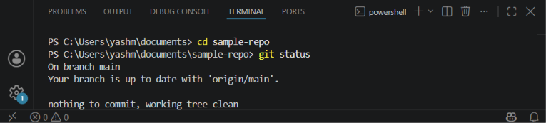

Step 2: Create the feature-login Branch
Create and switch to the required branch:
git checkout -b feature-login
Verify the branch:
git branch
The output should show:
* feature-login
Main

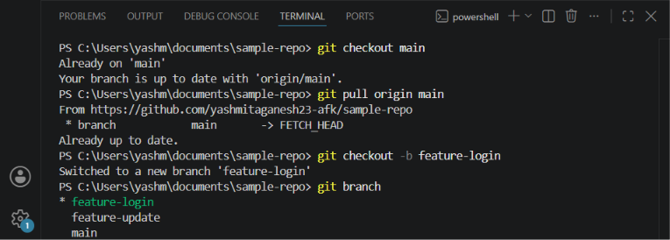

Step 3: Create login.py
Create a new file named:
login.py
Add the following login function:
def login(username, password):
if username == "admin" and password == "1234":
return "Login successful"
else:
return "Invalid username or password"
Save the file.
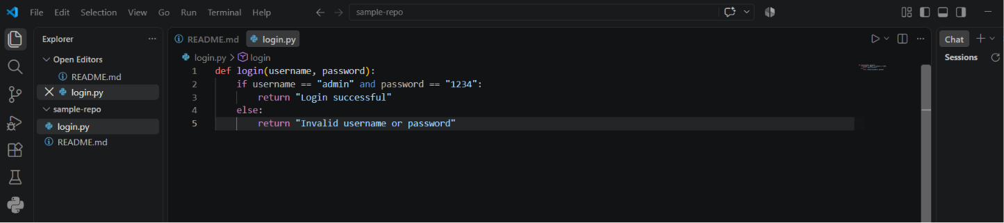
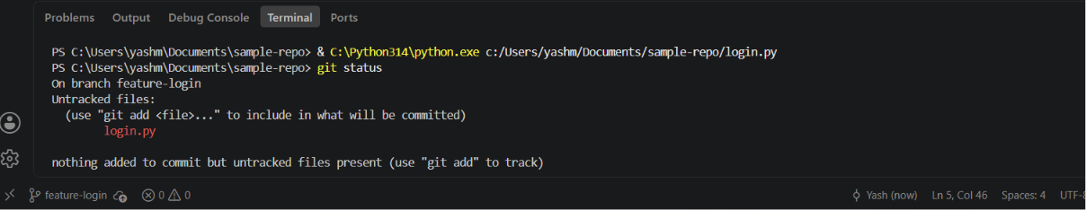

Step 4: Stage the File
Check the repository status:
git status
Then stage the new file:
git add login.py
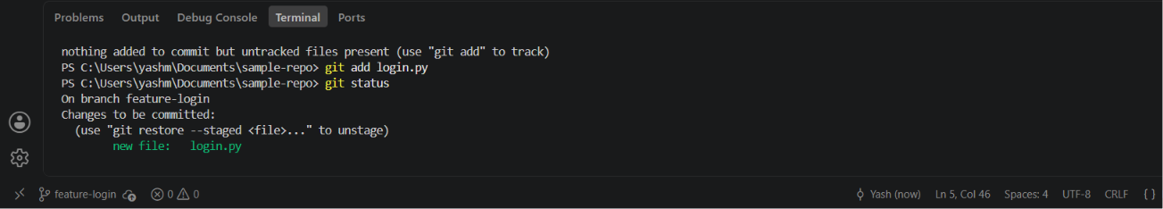

Step 5: Commit the Changes
Commit the login functionality:
git commit -m "Add login functionality"
The changes are now recorded in the local feature-login branch.
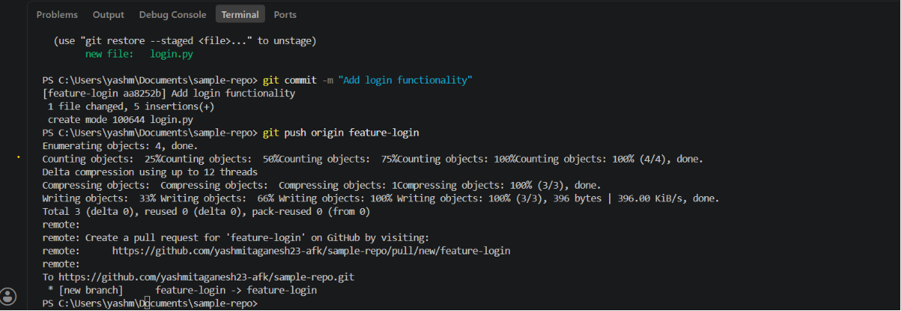

Step 6: Push the Feature Branch
Push the branch to GitHub:
git push origin feature-login
The feature-login branch is now available on GitHub.
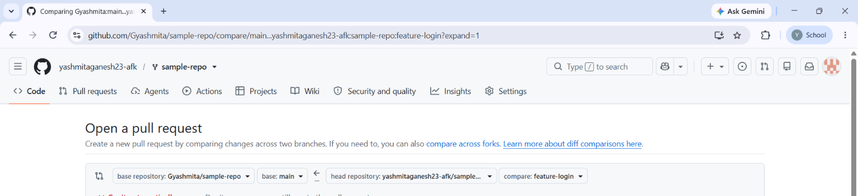

Step 7: Create a Pull Request
Open the GitHub repository in a web browser.
Go to:
Pull requests → New pull request
Select:
Base: main
Compare: feature-login
The pull request direction should be:
feature-login → main
Enter the title:
Add login functionality
Enter a suitable description:
Implemented a simple login function in login.py.
The function validates the username and password
and returns the appropriate login status.
Click:
Create pull request
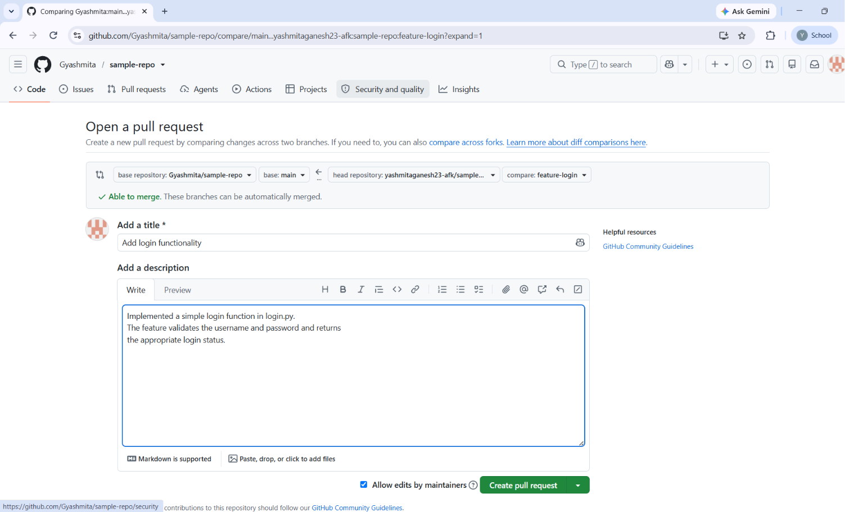

Step 8: Review the Pull Request
Open the created pull request.
Go to:
Files changed
Verify that login.py contains the implemented login function.
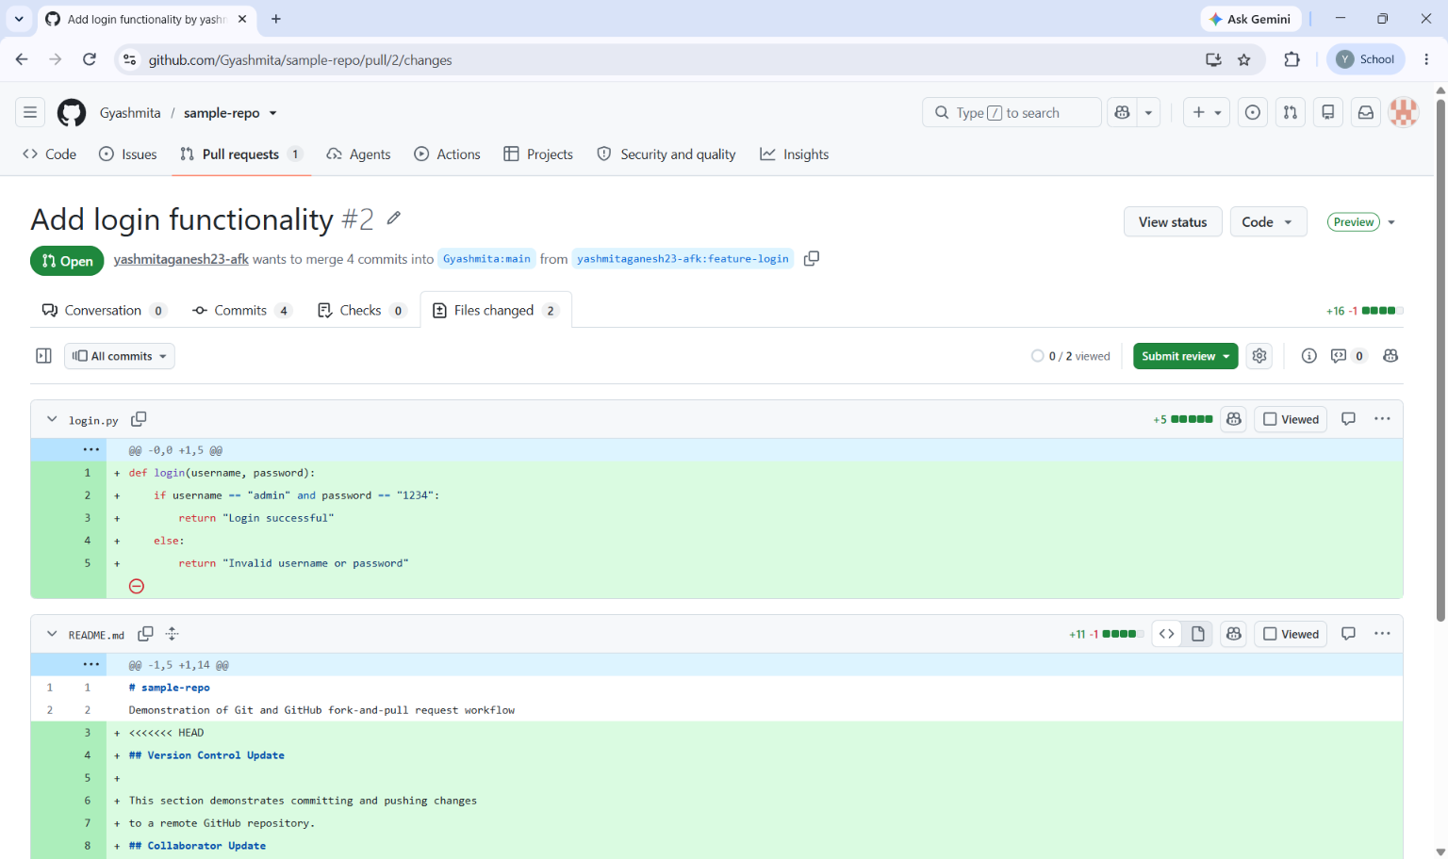

Step 9: Resolve Any Merge Conflict
If GitHub reports a merge conflict, resolve the conflict before merging.
The conflicting file can be opened in Visual Studio Code and the conflicting sections can be resolved. After resolving the conflict, save the file and commit the resolution.
For example:
git add README.md
git commit -m "Resolve merge conflict with main"
git push origin feature-login
After pushing, refresh the pull request and verify:
No conflicts with the base branch

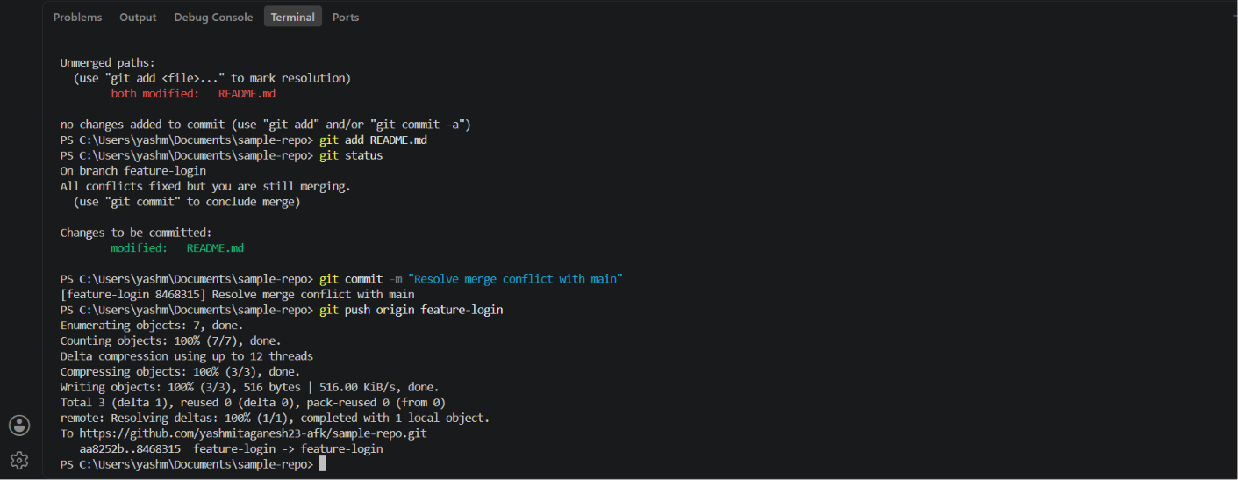

Step 10: Merge the Pull Request
After reviewing the changes and confirming that there are no conflicts:
Click:
Merge pull request
Then click:
Confirm merge
The pull request will be merged into the main branch.

Step 11: Verify the Merge
Open the repository and select the:
main
branch.
Verify that login.py is present in the main branch.
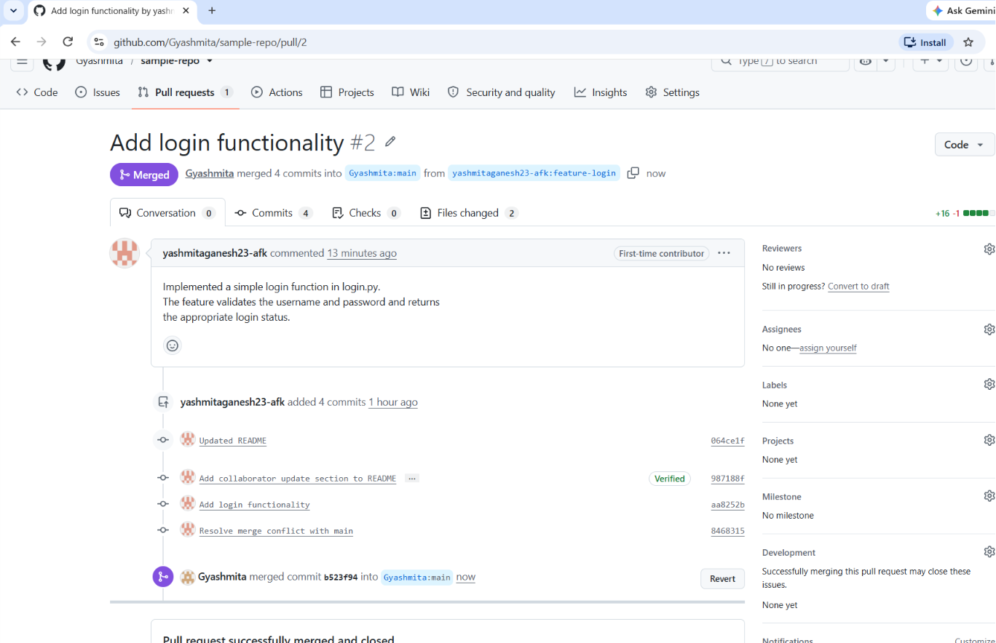

Commands Used
git checkout -b feature-login
git branch
git status
git add login.py
git commit -m "Add login functionality"
git push origin feature-login
If a merge conflict occurs:
git add README.md
git commit -m "Resolve merge conflict with main"
git push origin feature-login

Result
A feature-login branch was successfully created and used to implement a simple login function. The changes were committed and pushed to GitHub, followed by creation and review of a pull request. The feature branch was successfully merged into the main branch.

